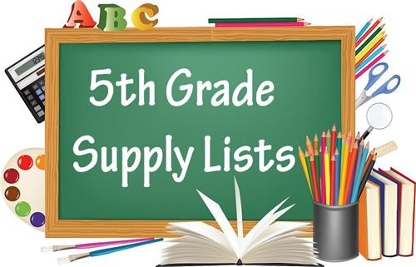
Cortland Elementary
School Supply List
2022-2023
FIFTH GRADE
Mr. Woodard

Dear Parent(s) / Guardian(s),

Things that you will need to supply
· 1 pair of scissors
· 1 Notebook (wide rule)
· Accordion File Folder (7 pockets)
· Pencil box
· 1 Crayon 24 pack
· Clear Ruler
· 1 12 pack of Colored pencils
· 1 24 pack #2 Pencils (NO MECHANICAL PENCILS)
· 1 Glue stick
· 2 Pack of wide rule filler paper
· 2 Boxes of Kleenex
· Backpack
· 1 12 Pack Black Dry Erase Markers
· 1 Pack Multi-Color Dry Erase Markers
· 1 Variety pack of Highlighters
BOYS 1 box of GALLON zip lock bags
GIRLS 1 box of sandwich zip lock bags

