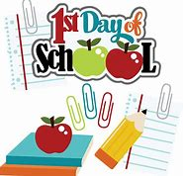
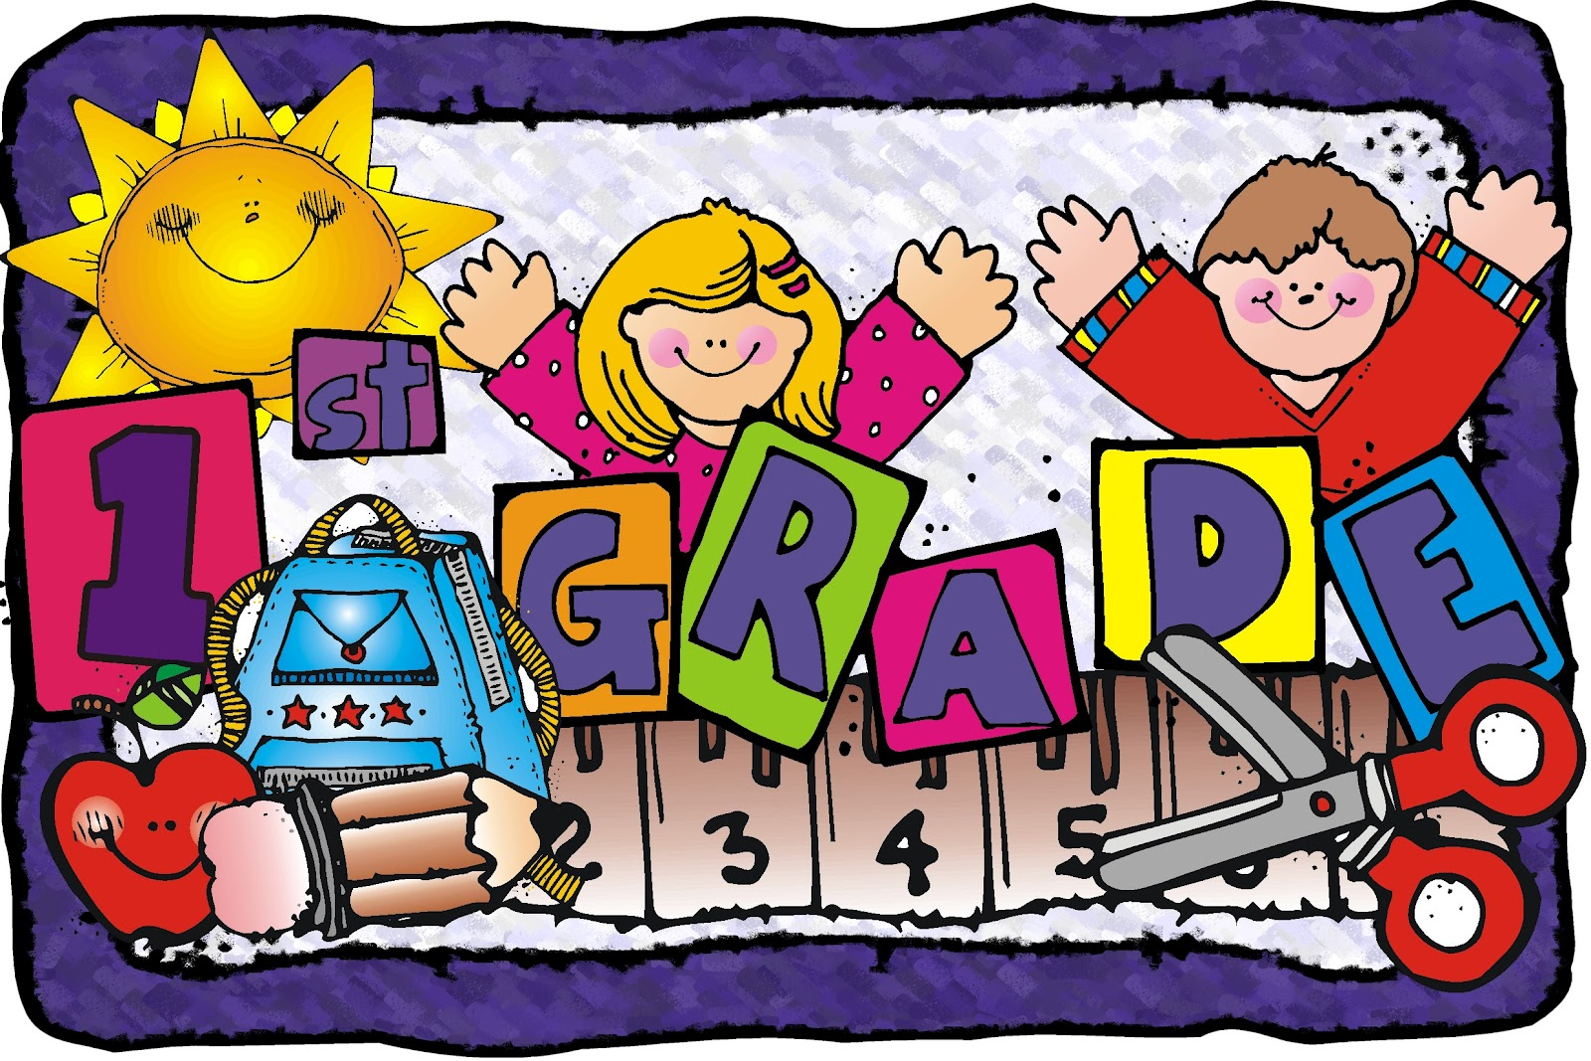
Cortland Elementary
School Supply List
2023-2024
FIRST GRADE
Mrs. Campbell

Dear Parent(s) / Guardians(s).

Things that you will need to supply:

1 Composition book (non-spiral bound-black & white)
2 packages of 24 Crayola crayons
1 small plastic pencil box
1 pair of blunt Fiskar children’s scissors
1 backpack
2 packs of #2 yellow pencils (no mechanical pencils)
2 pink pearl erasers
6 glue sticks
2 boxes of Kleenex
1 spiral notebook
4 two-pocket fastener folders (w/3 metal prongs to hold papers inside)
3 Highlighters (any color)
2 containers of disinfecting wipes
1 bottle of hand sanitizer

If you can help, we will also need the following:
Ziploc slide lock baggies (snack, quart, & gallon size)
Swiffer dusters
Extra Kleenex
Extra Hand sanitizer

***Generics are fine for all items

Please do not send pencil sharpeners with your child.
Thank you!

