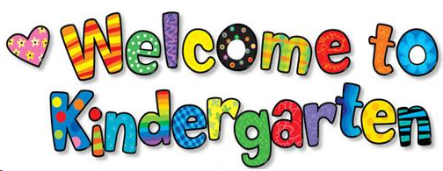
Kindergarten School Supply List
2023-2024
Cortland Elementary School
Teacher: Mrs. Fallis

- Backpack – please be sure the backpack is large enough to hold a folder.
- Zipper Pencil Pouch
- 1 package regular size #2 pencils
- 2 erasers- white Hi-Polymer erasers are great and easy to use. No pencil top erasers, please.
- 1-4 oz bottle of Elmer’s glue
- Crayons - 2 boxes - 24 count Crayola crayons
- Crayons - 2 boxes - 8 count Crayola Large Crayons
- 1 pair of blunt-tip scissors
- 4 boxes of tissue
- 4 fun folders with center clasps (can be any color and design)
- 3 plain folders (1 red, 1 yellow, 1 blue)
- Dry-erase markers (4 pack of black, thin, or fine markers)
- 1 Composition Notebook
- 2 Sharpie Tank Style highlighter - any color
- Box quart-size zip lock bags
- Box gallon-size zip lock bags
- 1 bottle of hand sanitizer

Please send supplies to school in a plastic bag.
Please do not label supplies. I will take care of items that need to be labeled. Some items will be used as “community” supplies.
Please do not send pencil sharpeners.
Feel free to bring these items to Kindergarten orientation or Open House to avoid over-filled bags on the first day of school.
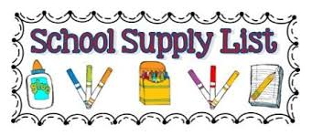
Thank You!

