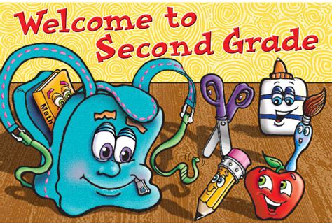
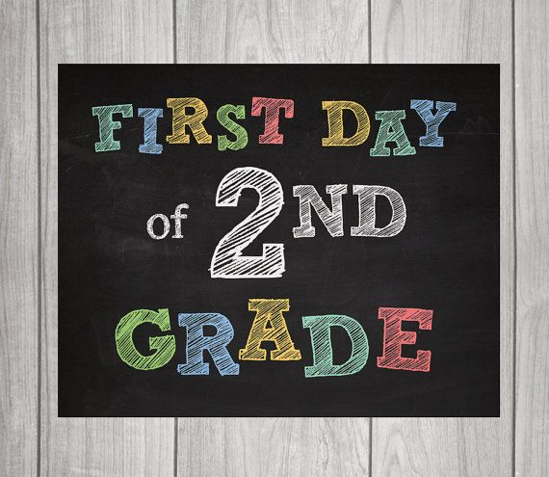
Cortland Elementary
School Supply List
2023 - 2024
SECOND GRADE
Mrs. Woodard

Dear Parent(s) / Guardians(s).

Things that you will need to supply:

2 packs of plain yellow #2 pencils (no mechanical)
1 pencil box or pencil bag
1 pair of pointed-tip scissors
(2) 2-pocket folders
2 wide-ruled spiral notebooks
2 boxes of Kleenex
Backpack or book bag
1 package of 24-count crayons
1 dry-erase marker (any color)
1 glue stick
1 eraser
1 set of addition flashcards (to have at home)
1 set of subtraction flashcards (to have at home)
1 box of sandwich-size ziplock bags
1 box of gallon-size ziplock bags
1 container of sanitizer wipes
1 bottle of hand sanitizer

Thank you!

