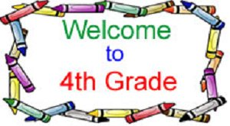
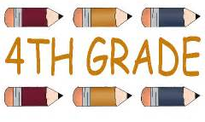
Cortland Elementary
School Supply List
2023-2024
FOURTH GRADE
Mrs. Birdsong

Dear Parent(s) / Guardian(s),

Things that you will need to supply

· 1 - Composition Notebook Wide rule
· 1 - Pencil pouch 9.8" x 7" (no boxes)
1- pair of scissors
· 1 - accordion file (5, 6, or 7 pockets)
· 36 #2 Pencils (no mechanical)
· 10 Pack Dry Erase Markers (any color)
1 dry erase Eraser
· 2 Ink pens in any color
· 2 Highlighter
· 1 Package of 24 Crayola crayons
· 3 glue sticks
· 1 12-Pack of colored pencils
· 1 box of tissues (to share)
1 box ziplock bags quart or gallon (to share)
1 container of Clorox wipes

NO hand-held pencil sharpeners.

Thank you

